How to Draw a Village

This charming village scene has it all -- a church, a house, and a barn against the backdrop of a sunset. Best of all, it’s easy to draw with the help of our simple instructions.


In this section, we'll show you how to draw this village landscape. You can draw it freehand while looking at your computer monitor, or you can print out this page to get a closer look at each step.

Here, we'll show you an illustration of each step and then give you a description of how to draw it. Follow the red lines in each illustration to learn exactly what to draw in that step. The lines drawn in previous steps are shown in gray.

To start your village landscape, sketch a horizontal line slightly below the middle of the page.

Step 1: Sketch a horizontal line slightly below the middle of the page. Draw the first tree line just above the horizontal line, using an unbroken squiggly line. For each building, use a ruler to make three straight vertical lines parallel to one another.

For the two buildings on the left, connect two of the lines with an inverted V shape. Then draw the roof as a slanted rectangle. For the barn on the right, connect two of the vertical lines with two angled lines as shown. Use two slanted rectangles for the roof.

To draw this village landscape, add windows and doors to the buildings with small squares and rectangles.

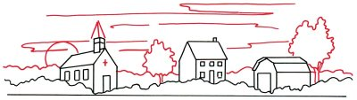
Step 2: Continue by adding windows and doors to the buildings with small squares and rectangles. The vertical lines should be parallel. Begin drawing a church steeple for the building on the left with a two-sided boxlike shape. Add a small square to the middle house for a chimney. Draw a second line near the roofline of the barn to give it depth.

To draw this village landscape, draw long, slightly jagged lines to show wispy clouds.


Step 3: Add a second tree line above the first one to show trees in the background. Finish the top of the steeple with two triangular shapes, and place a cross directly above the door. Draw two irregular, rounded shapes for trees. Use slightly curved lines for the trunks. Position part of a circle for the sun near the horizon. Draw long, slightly jagged lines to show wispy clouds.

To draw this village landscape, add a doorknob to each building with a dot.
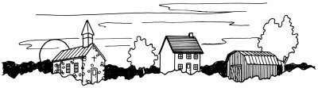

Step 4: For the church, give texture to the roof with diagonal lines. Use horizontal lines for the roof of the house. For the roof of the barn, use angled lines that follow the shape of the roof. Show panes in the windows with crosses, as shown. Draw a rectangle in the door of the house and the church. Add a doorknob to each with a dot. Use a combination of V-shaped and horizontal and vertical lines for boards on the barn door.

To finish your village landscape drawing, create wooden siding on the barn with vertical lines.
Step 5: Darken the upper tree line in the background to separate it from the lower one in the foreground. Place a series of tiny round and oval shapes at random on the walls of the church for a stonelike effect. Create the appearance of wooden siding on the barn with a series of vertical lines.

Your landscape drawing is finished! Even if you don't get it right the first time, keep practicing until you're happy with your drawing. In the next section, a canopy of trees covers a peaceful rural lane.

